**ML Zoomcamp 8.4 - Convolutional Neural Networks**

25

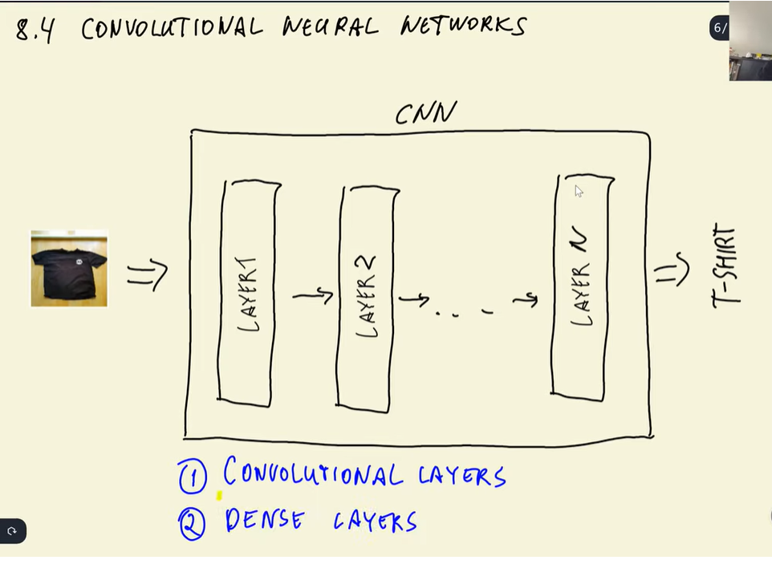

**Convolutional layers:**

Filters like small images

Simple shapes

We tke our image and slightly filter across the image

Check how similar it is to part of images

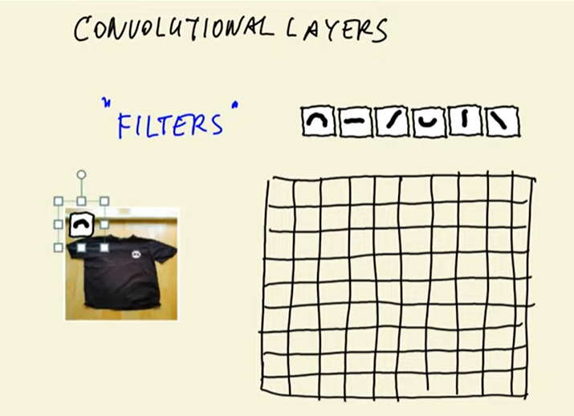

Take image where part is on (found)

Feature map

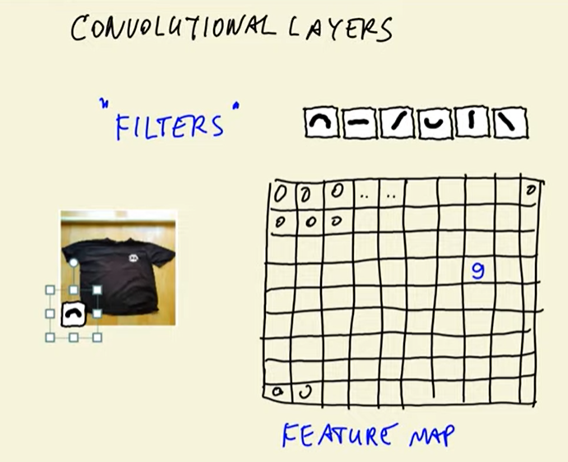

Higher value --? Higher similarity

{

Multiple feature map

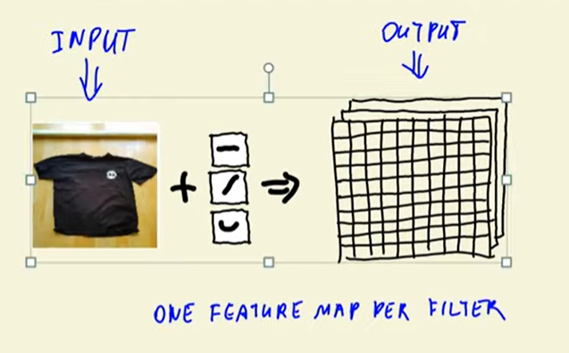

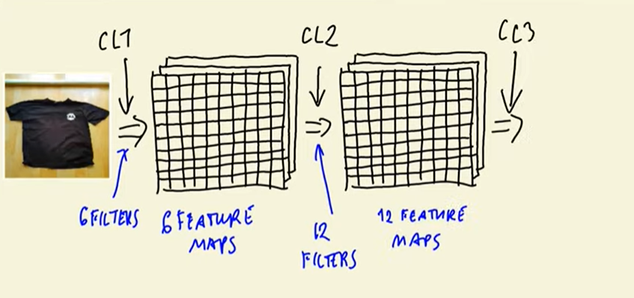

Each conv layr can get more and more filters

Layer learn features

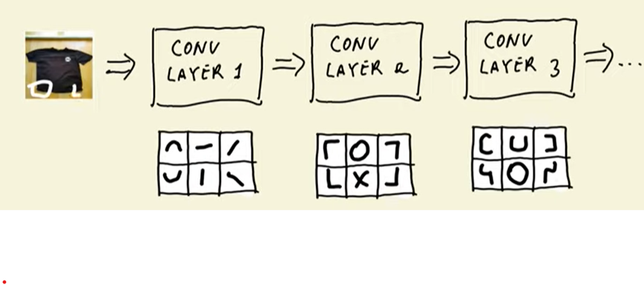

Higher level of features:

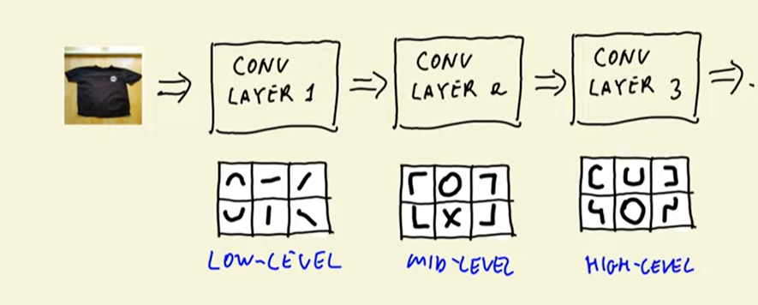

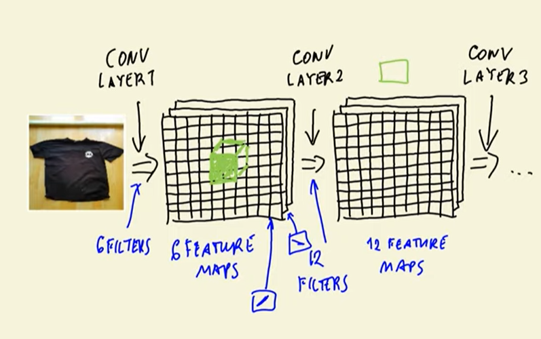

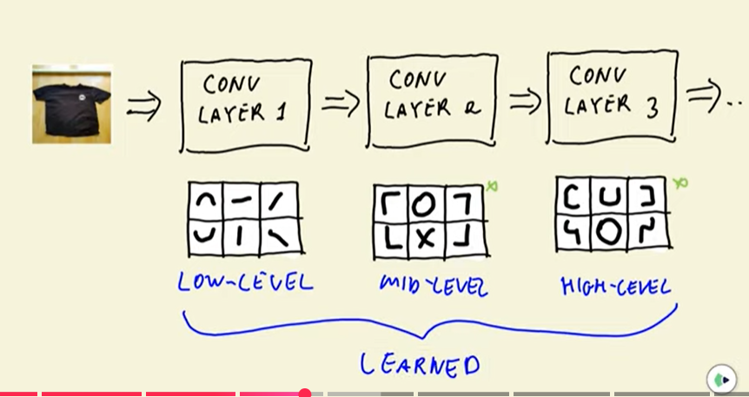

Out of these we get the vectore representation of the image

Vector representation

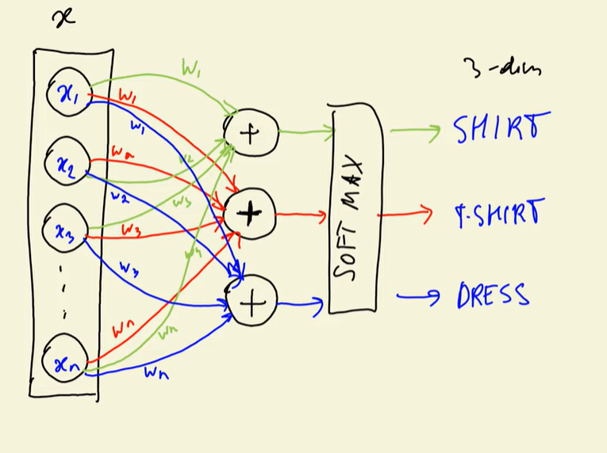

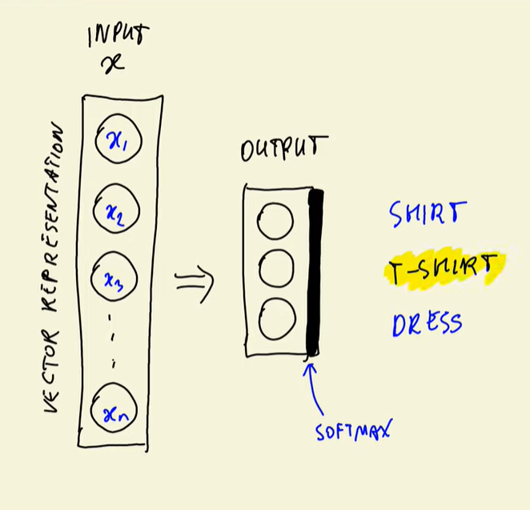

Dense layer

Called so because it connects each element of input to each element of output

dense layer is nothing but matrix multiplication

Tshirt image

To vectore representation

Then desnse layer to final prediction

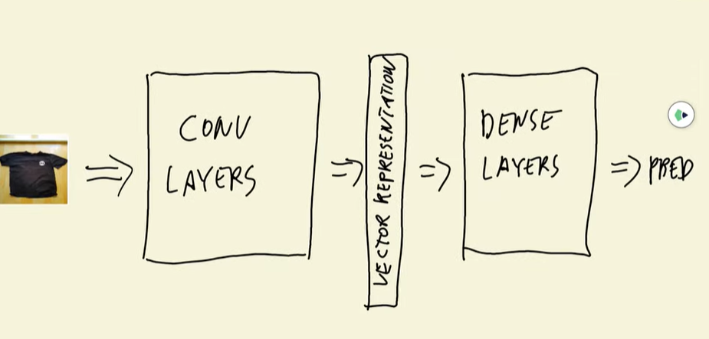



poling layer

to have fewer parameters

